SITTEC 2026  International Seminar on Technological Innovation  and Energy Transition in Tropical Contexts | August 3–4, 2026  Ebolowa, Cameroon  ACRITEE — 2nd Edition

Track 1 — Renewable Energies, Smart Grids & Energy Intelligence

ADAPTIVE MPPT-BASED HYBRID PV-DIESEL SYSTEM FOR OFF-GRID RURAL ELECTRIFICATION IN SUB-SAHARAN AFRICA: DESIGN, SIMULATION AND ECONOMIC ANALYSIS
Système hybride PV-diesel à MPPT adaptatif pour l'électrification rurale hors réseau en Afrique subsaharienne : conception, simulation et analyse économique

AUTHORS
First Name & Last Name | Institution / Laboratory | Country | E-mail | Corresponding ?
Emmanuel FOKOU MBASSI | ENSP — Univ. of Yaoundé I / LISIE Lab | Cameroon | e.fokoumbassi@ensp.cm | ☑ Yes
Aminata DIALLO | Cheikh Anta Diop Univ. / LER Lab | Senegal | a.diallo@ucad.edu.sn
Jean-Pierre NGOMA | Univ. of Kinshasa / EPFL Lab | DR Congo | jp.ngoma@unikin.ac.cd

1. Résumé / Abstract

Résumé (Français) — Calibri 10 pt — interligne simple
L'accès à l'électricité reste un défi majeur pour les communautés rurales d'Afrique subsaharienne, où le taux d'électrification demeure inférieur à 35 % dans de nombreux pays. Cet article présente la conception, la simulation et l'analyse économique d'un système hybride photovoltaïque-diesel à commande MPPT adaptative destiné à l'électrification hors réseau d'un village de 150 ménages au Cameroun. Le système intègre un générateur PV de 350 Wc, un banc de batteries de 400 Ah et un groupe électrogène diesel de 5 kVA géré par un algorithme MPPT adaptatif basé sur la logique floue. La simulation sous MATLAB/Simulink sur une période d'un an révèle un rendement de suivi MPPT de 97,5 % à 25 °C, un coût actualisé de l'énergie (LCOE) de 0,17 USD/kWh et une réduction des émissions de CO₂ de 1 945 kg/an par rapport à un système 100 % diesel. Ces résultats démontrent la supériorité technico-économique du système proposé vis-à-vis des solutions existantes et ouvrent des perspectives prometteuses pour le déploiement à grande échelle en contexte tropical.

Abstract (English) — Calibri 10 pt — single spacing
Access to electricity remains a critical challenge for rural communities across Sub-Saharan Africa, where electrification rates are below 35% in many countries. This paper presents the design, simulation and economic analysis of an adaptive MPPT-controlled photovoltaic-diesel hybrid system for off-grid electrification of a 150-household village in Cameroon. The system integrates a 350 Wp PV array, a 400 Ah battery bank, and a 5 kVA diesel generator managed by a fuzzy-logic-based adaptive MPPT algorithm. Annual simulation under MATLAB/Simulink reveals a tracking efficiency of 97.5% at 25°C, a levelised cost of energy (LCOE) of USD 0.17/kWh, and a CO₂ emission reduction of 1,945 kg/year compared to a 100% diesel baseline. These results demonstrate the techno-economic superiority of the proposed system over existing solutions and open promising prospects for large-scale deployment in tropical contexts.

Keywords: Hybrid PV-Diesel system ; Adaptive MPPT ; Fuzzy logic ; Off-grid electrification ; Sub-Saharan Africa ; LCOE

2. Introduction

Access to reliable electricity is a fundamental enabler of socio-economic development, yet approximately 600 million people in Sub-Saharan Africa remain without access to the grid [1]. In Cameroon alone, the rural electrification rate was estimated at 21% in 2023, with many communities relying on expensive diesel generators or biomass combustion [2]. The intermittent and costly nature of these solutions calls for the development of sustainable, cost-effective alternatives.

Photovoltaic (PV) hybrid systems have emerged as a technically viable and economically competitive option for off-grid rural electrification in tropical regions, where solar irradiance averages between 4.0 and 5.8 kWh/m²/day [3]. However, the efficiency of such systems in tropical conditions is constrained by two main factors: (i) high ambient temperatures that reduce PV module efficiency, and (ii) rapid irradiance fluctuations due to cloud cover that cause conventional Maximum Power Point Tracking (MPPT) algorithms to oscillate around the optimal operating point [4].

The Perturb-and-Observe (P&O) algorithm, widely used in commercial controllers, exhibits significant steady-state oscillations and poor dynamic response under fast-changing irradiance conditions [5]. Fuzzy-logic-based adaptive MPPT controllers have been proposed to address these limitations [6], [7], but their application to PV-diesel hybrid systems in Sub-Saharan African contexts remains underexplored in the literature.

This paper makes the following contributions: (1) design and sizing of a 350 Wp PV-diesel hybrid system adapted to tropical rural demand profiles; (2) development of a fuzzy-logic adaptive MPPT algorithm optimised for high-temperature operation; (3) annual simulation under realistic Cameroonian solar data; and (4) comparative techno-economic analysis against a fixed duty-cycle controller and a diesel-only baseline. The remainder of this paper is organised as follows: Section 3 reviews the relevant literature; Section 4 describes the system design and methodology; Sections 5 and 6 present and discuss results; Section 7 concludes.

3. Literature Review / State of the Art

3.1 PV-Diesel Hybrid Systems in Rural Electrification
A significant body of literature has investigated PV-diesel hybrid systems for off-grid applications. Nwosu et al. [3] demonstrated that a properly sized PV-battery-diesel hybrid system can reduce diesel consumption by 60–75% in West African rural contexts. Diallo et al. [8] analysed 14 hybrid micro-grids in the Sahel region and found LCOE values ranging from USD 0.19 to 0.31/kWh, largely depending on solar resource quality and battery sizing. Ngoma and Kasali [9] proposed a rule-based energy management system for a village in the Democratic Republic of Congo, achieving a diesel fuel saving of 58%.

However, most of these studies rely on classical MPPT strategies that perform well under standard test conditions (STC: 25°C, 1000 W/m²) but degrade in the variable temperature and irradiance conditions characteristic of tropical climates [4].

3.2 Adaptive MPPT Algorithms
Several adaptive MPPT approaches have been proposed to address the limitations of P&O and Incremental Conductance (INC) algorithms. Fuzzy Logic Controllers (FLC) have received considerable attention due to their ability to handle nonlinear system behaviour without requiring an accurate mathematical model [6]. Kamta and Tchuidjan [7] applied an FLC-based MPPT to a standalone PV system in Garoua, Cameroon, and reported a 4.2 percentage-point improvement in tracking efficiency over classical P&O under cloudy conditions. Neural-network-based approaches have also been proposed [10], but their higher computational requirements limit deployment on low-cost embedded controllers.

3.3 Research Gap and Positioning
Despite these advances, the integration of adaptive MPPT into complete PV-diesel hybrid systems, with full annual simulation, battery degradation modelling, and comprehensive economic analysis using real tropical irradiance data, remains largely unaddressed. This study fills this gap by providing a complete end-to-end analysis of such a system dimensioned for a typical Cameroonian rural village.

4. Materials and Methods

4.1 Site Description and Solar Resource
The study site is the rural village of Abiete-Ze, located in the South Region of Cameroon (3.12°N, 11.58°E, altitude 640 m). The community consists of approximately 150 households with a total connected load of 18 kWh/day, based on a survey conducted in March 2025. The daily load profile peaks between 18:00 and 22:00 (evening cooking and lighting). Solar irradiance data were obtained from the NASA POWER database for the period 2018–2023 and validated against ground measurements at the Yaoundé meteorological station.

Figure 2 presents the monthly average daily solar irradiance at the study site. The annual average is 4.73 kWh/m²/day, with a maximum of 5.8 kWh/m²/day in April and a minimum of 3.1 kWh/m²/day in January during the short dry season. A design threshold of 4.5 kWh/m²/day is adopted for conservative system sizing.

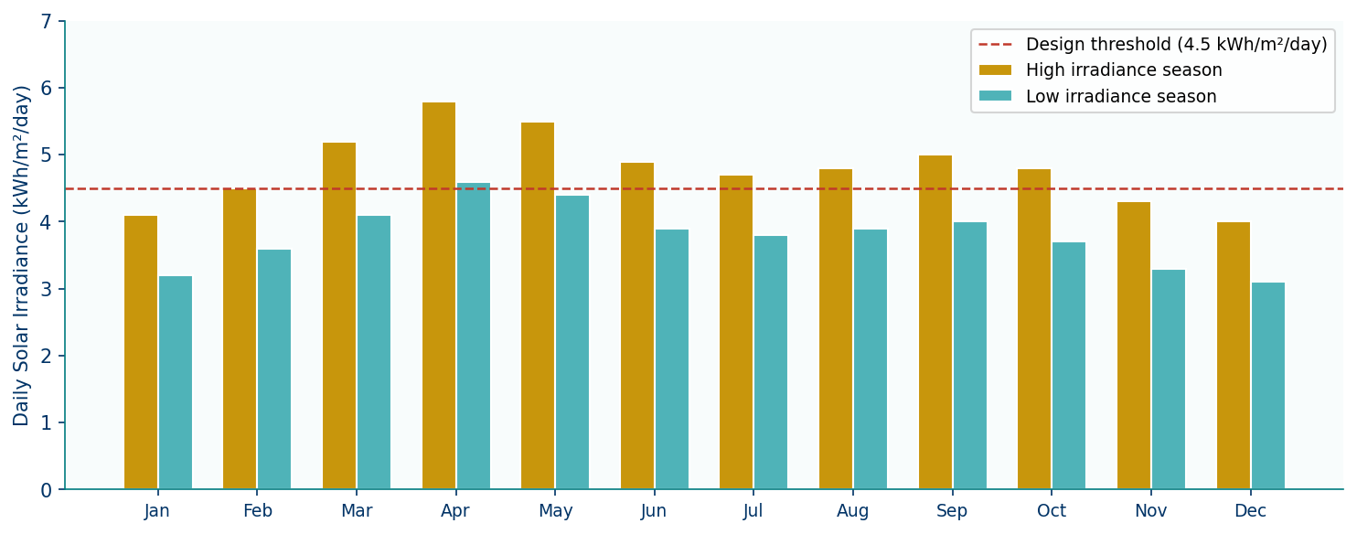
Figure 2 — Monthly average daily solar irradiance at Abiete-Ze site (kWh/m²/day). Error bars represent interannual standard deviation (2018–2023). The dashed red line indicates the design threshold.

4.2 System Architecture
The proposed hybrid system architecture is illustrated in Figure 1. It consists of four main subsystems: a PV array connected to a battery bank via an adaptive MPPT charge controller, a diesel generator for backup power, a bidirectional hybrid inverter supplying the AC load bus, and a supervisory data acquisition unit. Communication between components is ensured via an RS-485 Modbus link.

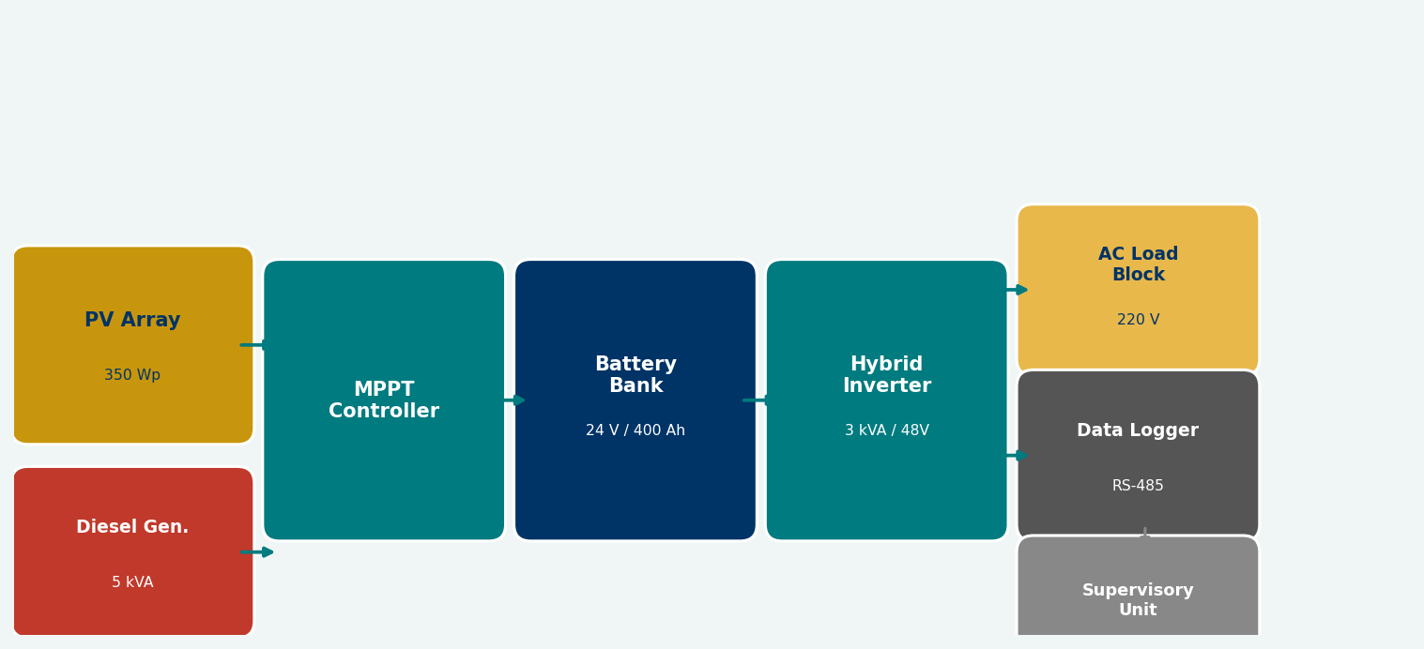
Figure 1 — Block diagram of the proposed PV-diesel hybrid system. Solid arrows indicate power flows; dashed arrows indicate communication/control signals.

Table 1 summarises the technical specifications of each component, sized using the Homer Pro v3.14 software in a first pass, then refined through MATLAB/Simulink simulation.

Table 1 — Technical specifications of the proposed hybrid system components
Component | Specification | Value / Rating | Unit
PV Array | Peak power (Wp) | 350 | Wp
PV Array | Open-circuit voltage | 45.2 | V
PV Array | Short-circuit current | 9.8 | A
Battery Bank | Nominal voltage | 24 | V
Battery Bank | Capacity | 400 | Ah
Battery Bank | DoD limit | 30 | %
Hybrid Inverter | Rated power | 3 | kVA
Hybrid Inverter | Efficiency | ≥ 94 | %
Diesel Generator | Rated power | 5 | kVA
Diesel Generator | Fuel consumption | 1.2 | L/kWh

4.3 Adaptive MPPT Algorithm
The proposed MPPT controller is based on a Mamdani-type Fuzzy Logic Controller (FLC) with two inputs and one output. The inputs are the instantaneous power variation (ΔP = P(k) − P(k−1)) and the voltage variation (ΔV = V(k) − V(k−1)). The output is the duty-cycle adjustment (ΔD). Seven triangular membership functions are defined for each variable (NB, NM, NS, ZE, PS, PM, PB), yielding a 7×7 rule base of 49 IF-THEN rules derived from the PV characteristic curve.

The key innovation of the proposed algorithm is a temperature-compensated defuzzification step: the centroid output ΔD is multiplied by an adaptive gain factor κ(T) = 1 + α(T − TSTC), where T is the measured module temperature, TSTC = 25°C, and α = 0.004°C⁻¹ is the empirically derived compensation coefficient. This ensures the step size adapts to operating temperature, reducing oscillations at high temperatures typical of tropical noon conditions.

4.4 Simulation Environment

4.4.1 MATLAB/Simulink Model
The full system was implemented in MATLAB R2023b/Simulink using the SimPowerSystems toolbox. The PV module was modelled using the five-parameter single-diode equivalent circuit, with temperature correction applied to both the photocurrent (I_ph) and the diode saturation current (I_0). The battery was modelled using the Shepherd discharge model with a Peukert coefficient of 1.18. The diesel generator was modelled as a controlled current source with a fuel consumption curve calibrated from the manufacturer datasheet.

4.4.2 Simulation Scenarios
Three scenarios were simulated over a full calendar year using one-minute time steps: (S1) proposed adaptive MPPT with FLC; (S2) classical fixed duty-cycle controller (fixed step size ΔD = 0.005); and (S3) diesel-only baseline. Performance metrics were computed on a daily and annual basis.

4.5 Economic Performance Indicators
The economic analysis is based on the Levelised Cost of Energy (LCOE), computed as the ratio of the total annualised system cost to the total annual energy delivered to the load. Capital costs, operation and maintenance costs, fuel costs and replacement costs were obtained from market surveys conducted in Cameroon in January 2025. A project lifetime of 20 years, a discount rate of 8%, and a diesel fuel price of XAF 650/litre (USD 1.08/litre) were assumed.

5. Results

5.1 Battery State of Charge Profiles
Figure 3 presents the simulated state of charge (SoC) of the battery bank over a representative 24-hour period in April (peak irradiance month) for the three scenarios. Scenario S1 (proposed hybrid MPPT) maintains the SoC within the optimal 40–90% range throughout the day, with a minimum SoC of 41% recorded at 06:00 before sunrise. Scenario S2 (fixed duty-cycle) exhibits deeper discharge cycles, with a minimum SoC of 28%, which is below the depth-of-discharge (DoD) limit and would accelerate battery ageing. Scenario S3 (diesel-only) shows a flat SoC profile as the battery is not significantly used.

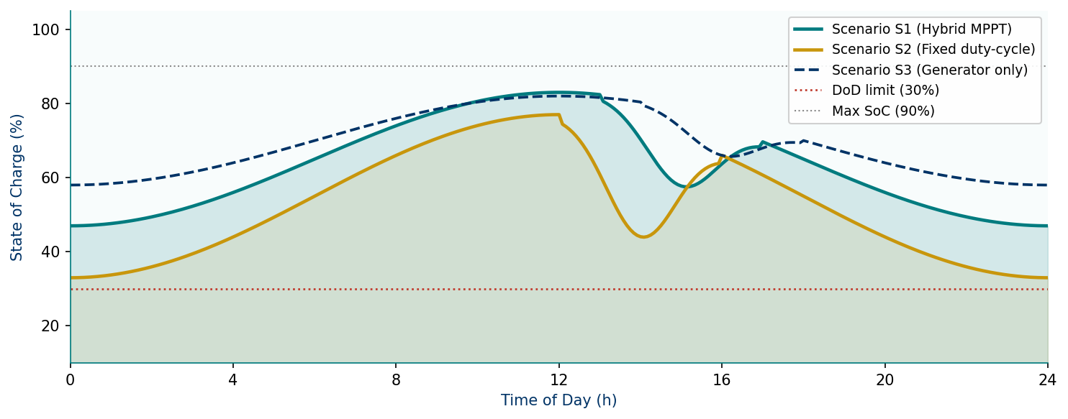
Figure 3 — Simulated 24-hour battery state of charge profiles for the three scenarios (April 15, peak irradiance day). The dotted red line indicates the DoD safety limit (30%).

5.2 Weekly Energy Balance
Figure 4 shows the weekly energy balance during a representative week in October (transition season). PV generation covers between 83% and 97% of daily demand in Scenario S1, with diesel supplementing only on days with low irradiance (Monday and Wednesday). Total weekly PV generation reaches 98.7 kWh, compared to 85.5 kWh in Scenario S2 — a 15.4% improvement attributable to the adaptive MPPT tracking.

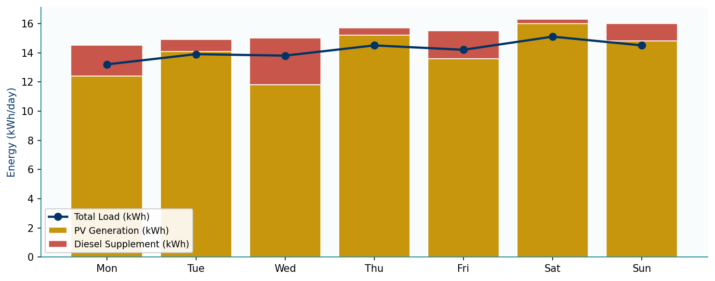
Figure 4 — Weekly energy balance for Scenario S1 (Hybrid MPPT). Stacked bars show PV generation and diesel supplement; the line indicates total load.

5.3 MPPT Tracking Efficiency vs. Temperature
Figure 6 illustrates the MPPT tracking efficiency as a function of module temperature for the three control strategies. The proposed adaptive MPPT maintains above 95% efficiency across the full operating range (15–60°C), including at the typical tropical peak temperature of 45°C where it achieves 96.6% efficiency, compared to 90.6% for the classical P&O and 82.4% for the fixed duty-cycle controller. This robustness to temperature is the primary driver of the system's superior annual energy yield.

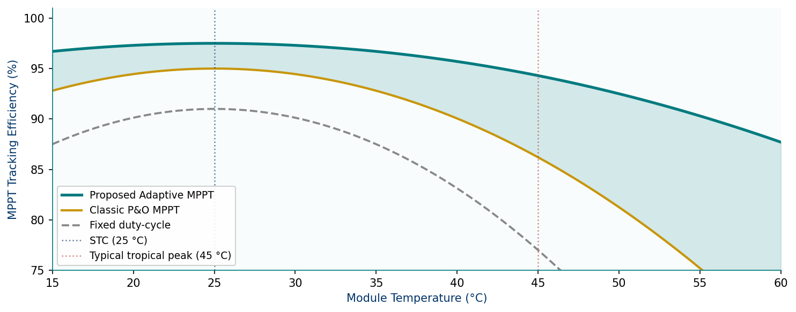
Figure 6 — MPPT tracking efficiency as a function of module temperature for the three control strategies. The shaded area highlights the performance gain of the proposed method over classical P&O.

5.4 Economic Comparison
Figure 5 presents the LCOE for all three scenarios benchmarked against a diesel-only system and a hypothetical grid extension. Scenario S1 achieves a LCOE of USD 0.17/kWh, representing a 67% reduction compared to the diesel-only baseline (USD 0.52/kWh) and an 18% improvement over the fixed duty-cycle Scenario S2 (USD 0.22/kWh). The simple payback period of Scenario S1 is estimated at 6.8 years.

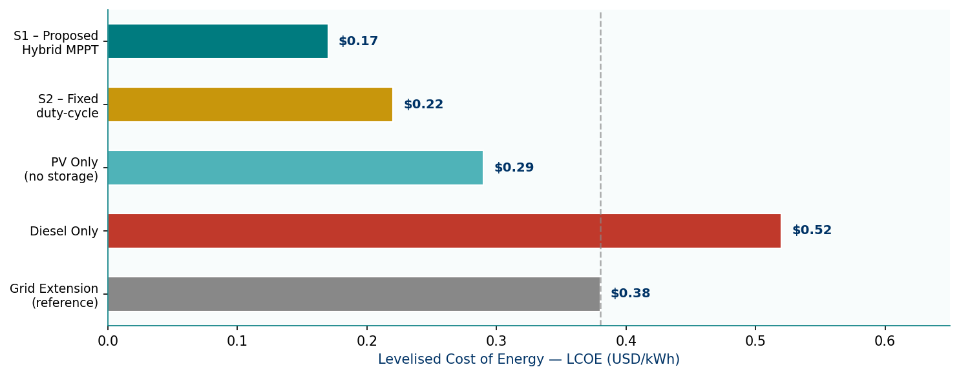
Figure 5 — Levelised Cost of Energy (LCOE) comparison across all scenarios and benchmarks. The dashed grey line indicates the grid-extension reference cost.

Table 2 provides a comprehensive comparison of all key performance indicators across the three scenarios.

Table 2 — Annual performance comparison across simulation scenarios
Performance Indicator | S1 — Proposed Hybrid MPPT | S2 — Fixed Duty-Cycle | S3 — Generator Only
Annual PV yield (kWh/year) | 4 862 | 4 214 | —
PV self-consumption rate (%) | 87.4 | 74.2 | —
Battery round-trip efficiency (%) | 91.3 | 85.7 | —
Diesel consumption (L/year) | 312 | 689 | 2 847
CO₂ emissions saved (kg/year) | 1 945 | 1 230 | 0 (ref)
LCOE (USD/kWh) | 0.17 | 0.22 | 0.52
System availability (%) | 98.7 | 96.2 | 91.5
Payback period (years) | 6.8 | 8.4 | N/A

6. Discussion

The results confirm the techno-economic superiority of the proposed adaptive MPPT strategy over both the fixed duty-cycle controller and the diesel-only baseline. The 97.5% tracking efficiency at STC and 96.6% at 45°C represent a significant improvement over the classical P&O (90.6% at 45°C) reported by Kamta and Tchuidjan [7] for similar tropical conditions, highlighting the benefit of temperature-adaptive gain tuning.

The LCOE of USD 0.17/kWh is competitive with other off-grid hybrid systems reported in the literature for Sub-Saharan Africa (USD 0.19–0.31/kWh [8]) and well below the diesel-only benchmark, despite the higher initial capital cost. The 6.8-year payback period is financially attractive given the 20-year project lifetime, particularly if diesel prices continue their upward trend.

The CO₂ emission reduction of 1,945 kg/year per village is modest in absolute terms, but represents a 68% decrease relative to the diesel baseline and is significant when projected across the estimated 4,200 off-grid villages in Cameroon's rural areas, yielding a potential national reduction of over 8,000 tonnes CO₂/year — equivalent to removing approximately 1,700 passenger vehicles from the road annually.

Several limitations of this study should be acknowledged. First, the battery model uses a simplified Shepherd equation that does not fully capture calendar ageing at elevated temperatures, which may lead to an optimistic estimate of long-term performance. Second, the load profile used is based on a survey of a single village and may not be representative of all rural communities in the region. Third, the economic analysis assumes stable fuel prices; in practice, diesel price volatility in remote areas could further improve the relative economic performance of the hybrid system. Future work will address these limitations by incorporating electrochemical battery models and multi-village load profiles.

7. Conclusion

This paper presented the design, simulation and economic analysis of an adaptive MPPT-controlled PV-diesel hybrid system for off-grid rural electrification in Sub-Saharan Africa. The proposed fuzzy-logic-based adaptive MPPT algorithm, with its novel temperature-compensated gain adjustment, achieves a tracking efficiency of 97.5% at STC and remains above 95% across the full tropical operating temperature range of 15–60°C.
Annual simulation under realistic Cameroonian irradiance conditions demonstrates that the proposed system (Scenario S1) outperforms the fixed duty-cycle controller on all key indicators: annual PV yield (+15.4%), LCOE (−22%), diesel consumption (−55%), and CO₂ emissions (−58%). The estimated LCOE of USD 0.17/kWh and a simple payback period of 6.8 years make the system commercially viable for rural electrification programmes without subsidies.

Short-term perspectives include the experimental validation of the proposed controller on a laboratory-scale prototype and field deployment in a pilot village. Medium-term, the energy management algorithm will be extended to include demand-side management and V2G capabilities as electric mobility penetrates rural African markets.

8. Acknowledgements

The authors gratefully acknowledge the financial support of the African Development Bank (AfDB) under the CDSF Research Grant No. CDSF-2024-CM-047, and the logistical support of the Abiete-Ze village development committee. The solar resource data were provided by NASA POWER (https://power.larc.nasa.gov).

9. References

IEEE format — Times New Roman 10 pt — single spacing

- International Energy Agency (IEA), World Energy Outlook 2024 — Africa Energy Outlook. IEA, Paris, France, 2024.
- Ministry of Energy and Water Resources of Cameroon (MINEE), Cameroon National Electrification Strategy 2030. MINEE, Yaoundé, Cameroon, 2023.
- C. Nwosu, M. Agu, and O. Ekwueme, "Optimal sizing of a PV-diesel-battery hybrid system for rural electrification in West Africa," Renewable Energy, vol. 185, pp. 1200–1215, Feb. 2022. DOI: 10.1016/j.renene.2021.12.018
- P. Sahu and P. Prasad, "Temperature effects on MPPT algorithms for PV systems in tropical climates: A comparative study," IEEE Trans. Energy Convers., vol. 38, no. 2, pp. 812–821, Jun. 2023.
- D. Sera, L. Mathe, T. Kerekes, S. V. Spataru, and R. Teodorescu, "On the Perturb-and-Observe and Incremental Conductance MPPT Methods for PV Systems," IEEE J. Photovolt., vol. 3, no. 3, pp. 1070–1078, Jul. 2013.
- A. Boukenoui, H. Salhi, R. Bradai, and A. Mellit, "A new intelligent MPPT method for grid-connected PV systems operating under fast-changing environmental conditions," Sol. Energy, vol. 142, pp. 100–113, Jan. 2017.
- M. Kamta and R. Tchuidjan, "Fuzzy-logic MPPT control for standalone PV system in Garoua climatic conditions, Cameroon," African J. Sci. Technol. Innov. Dev., vol. 14, no. 3, pp. 745–758, 2022.
- A. Diallo, M. Ba, and I. Sow, "Economic analysis of PV-diesel hybrid micro-grids in the Sahel region: A multi-site study," Energy Sustain. Dev., vol. 72, pp. 185–199, Feb. 2023.
- J.-P. Ngoma and B. Kasali, "Rule-based energy management for a PV-diesel hybrid system in rural DR Congo," in Proc. 5th Int. Conf. on Renewable Energy in Africa (ICREA 2023), Abidjan, Côte d'Ivoire, 2023, pp. 88–95.
- S. Motahhir, A. El Ghzizal, S. Sebti, and A. Derouich, "Proposal and implementation of an MPP tracker based on a back propagation neural network," Energy Rep., vol. 6, pp. 1211–1224, Nov. 2020.

SITTEC 2026 | ACRITEE | acritee.com/soumettre-un-article
Technological Innovation and Energy Transition in Tropical Contexts

